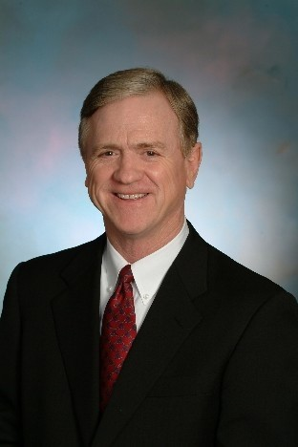  Michael L. Cooper  Food & Agribusiness Executive  The Food Group LLC  Food Industry Consulting  4825 E. Crystal Lane  Paradise Valley, Arizona 85253  Cell 602-510-6633  mcooper@krsearch.net  Function and specialization  Michael specializes in food, agribusiness and life sciences. From Farm to fork, he has developed strong leadership experience with a no nonsense, hands-on leadership style. His strengths include developing strong teams, deep and broad-based understanding of agriculture from 1st hand experience and a strong desire to help people – especially the average farm family in the US.  Representative companies served  - The Bill & Melinda Gates Foundation.  - Cargill, ADM, ConAgra  - Perdue Farms, Tyson Foods, Pilgrim’s Pride  - YUM! Brands  - Green Plains Renewable Energy  - Hormel Foods  - St. Mary’s Food Bank Alliance, Phoenix  - The Dial Corporation – Food Division  - Soybean Export Association  - The Peanut Board  - National Cattlemen’s Beef Association  - Family farmers  Professional associations  - Member Arizona Society of Certified Public Accountants (inactive)  - Member, American Institute of Certified Public Accountants, Global Certification  - Food Manufacturers Institute (FMI)  - National Association of Corporate Directors  - National Chicken Council & Turkey Federation  Education, licenses & certifications  - BS degree, Marketing, MBA Finance  Arizona State University  - Licensed CPA—AZ, VA, MD (inactive) | Background  Michael is a semi-retired partner and former owner of Kincannon & Reed, an executive search firm based in Northern Virginia, that focuses exclusively on food, agribusiness and life science sectors globally, with 60 offices covering North & South America, Europe and Asia. Prior to this role of evaluating and placing C-suite leaders in agribusinesses, Michael served as a President at Perdue Farms, leading the retail, foodservice and International divisions of the multi-billion-dollar family-owned food company. He was on the board of directors and concurrently served as the EVP & Chief Financial Officer. A part of that role was to serve as a member of the National Chicken Council and the National Turkey Federation. He is currently serving on the Board of Directors of the largest poultry company globally – Pilgrim’s Pride, driving growth for over a decade. Prior to Perdue, Michael was the EVP of Shady Brook Farms in Northern Virginia, a billion-dollar family-owned, turkey and chicken products company. He led initiatives to develop poultry businesses in China, Russia, Bulgaria and Belgium on behalf of the US-based business. Since then, he has been a driver of growth for US companies in Europe, Russia, China and South America. His financial acumen coupled with Ag industry leadership expertise and formal business experience provide a strong background to lead the industry. While serving on the National Turkey Federation’s Executive Council, Michael had the honor of presenting the holiday Turkey for pardon to then President Clinton at the White House, an annual event.  Michael has worked with the USDA, FDA, Department of Agriculture, EPA, the Food Safety Council and OSHA at various points in his career. He also worked with retail grocery chains and foodservice restaurant channels to ensure high quality food products made it safely to the consumer. Michael invested time and attention to understanding the entire food supply chain and the important role it plays in global food safety and feeding America. He has substantial experience leading business and industry and is as comfortable in food plants as he is in the boardroom.  In spite of a modest family farming background in West Central, Iowa, his roots are squarely tied to food and agribusinesses aspect of industry. Keenly aware of the need to represent the interests of those involved in agribusiness, he participated in badly needed changes in the Farm Bill and helped address changing tax implications that would harm family farmers who have invested generations feeding America. While not political in nature, Michael understands the need to collaborate, compromise and find common ground on issues of food industry importance. He came from poverty, worked hard to achieve success and views this work as some small way of giving back to deserving hard working, American families. His financial background provides a solid basis for understanding significant aspects of importance to business and industry.  Professional and industry experience  Michael remains closely connected to the industry in several ways. First, his family still farms in Iowa, a place that brings back fond memories from his youth, including memories of the hard work required to make a modest living in the Ag industry. And second, he wants to represent those family farmers who need support in DC to get a fair income from a fair days’ work. He is not an insider to the beltway, but not intimidated by the need to participate and lead.  Other activities  - Current Vice Chairman, Emeritus, Kincannon & Reed (Food & Agribusiness executive).  - Former member of the President Advisory Council of the Grocery Manufacturers Association (GMA).  - Board of Directors, Pilgrim’s Pride (Audit Committee Chairman, Compensation and Nominating Committee member), 2008 to present  - Former Board member of the Maryland YMCA , the Delmarva Peninsula Regional Medical Center and the President’s Council for the University of Maryland, Eastern Shore.

